Prithvi Dhirwani
D15C 25
MLDL
Practical 1: Implementation of Linear and Logistic Regression on Real-World Datasets

1. Dataset Source
Linear Regression Dataset
- Dataset Name: Advertising Dataset
- Source: Kaggle
- Link: https://www.kaggle.com/datasets/ashydv/advertising-dataset
Logistic Regression Dataset
- Dataset Name: Breast Cancer Wisconsin Dataset
- Source: Kaggle (UCI ML Repository)
- Link: https://www.kaggle.com/datasets/uciml/breast-cancer-wisconsin-data
Each algorithm uses a different real-world dataset, as required.

Here is the rewritten version in different words while keeping the same meaning and structure:

2. Dataset Overview
2.1 Advertising Dataset (Linear Regression)
Objective: Estimate product sales based on advertising spending across different media channels.
Total Samples: 200
Total Features: 4
Features
Feature | Explanation
TV | Amount spent on TV advertisements
Radio | Amount spent on radio advertisements
Newspaper | Amount spent on newspaper advertisements
Sales | Total product sales (output variable)
Target Variable: Sales (continuous numeric value)
Dataset Type: Regression
Main Characteristics:
- No missing or null values
- Fully numerical attributes
- Appropriate for linear regression analysis

2.2 Breast Cancer Dataset (Logistic Regression)
Objective: Identify whether a tumor is benign or malignant.
Total Samples: 569
Total Features: 30 numerical attributes
Target Variable: diagnosis
- 0 → Benign
- 1 → Malignant
Dataset Type: Binary Classification
Key Properties:
- Medical diagnosis dataset
- Well-structured and balanced feature set
- Frequently used as a benchmark for classification algorithms

3. Mathematical Representation of the Models
3.1 Linear Regression
Linear regression describes the relationship between an input variable (x) and an output variable (y) using a straight-line equation:
y = β₀ + β₁x + ε
Where:
- β₀ = Intercept
- β₁ = Slope (coefficient/weight)
- ε = Error term
The model aims to reduce the Mean Squared Error (MSE):
MSE = (1/n) Σ (yᵢ − ŷᵢ)²

3.2 Logistic Regression
Logistic regression applies the sigmoid (logistic) function to predict probabilities for binary outcomes:
σ(z) = 1 / (1 + e⁻ᶻ)
Where:
z = β₀ + β₁x₁ + β₂x₂ + … + βₙxₙ
The output gives the probability that a sample belongs to class 1.
The optimization objective is minimizing cross-entropy (log loss):
Loss = −(1/n) Σ [ y log(p) + (1 − y) log(1 − p) ]

4. Limitations of the Algorithms
4.1 Limitations of Linear Regression
- Assumes a linear relationship between predictors and target
- Highly affected by extreme values (outliers)
- Not suitable for complex non-linear patterns
- Sensitive to multicollinearity among features
4.2 Limitations of Logistic Regression
- Struggles with non-linear class boundaries
- Influenced by outliers
- Requires sufficiently large datasets for reliable probability estimates
- Assumes feature independence

5. Methodology / Procedure
General Steps
- Data acquisition
- Data preprocessing and cleaning
- Feature selection
- Splitting dataset into training and testing sets
- Model training
- Model performance evaluation
- Result visualization

5.1 Linear Regression Process
- Load the Advertising dataset
- Choose TV spending as the predictor and Sales as the response variable
- Divide the dataset into training and testing subsets
- Train the Linear Regression model
- Generate sales predictions
- Evaluate model using MSE and R² score
- Visualize:
  - Scatter plot of actual data
  - Fitted regression line

5.2 Logistic Regression Process
- Load the Breast Cancer dataset
- Convert diagnosis labels into numerical form
- Split dataset into training and test sets
- Train the Logistic Regression model
- Predict class labels and class probabilities
- Evaluate using accuracy and confusion matrix
- Visualize:
  - Distribution of classes
  - Confusion matrix
  - ROC curve

6. Performance Evaluation
6.1 Linear Regression Results
- Mean Squared Error (MSE): Measures prediction deviation
- R² Score: Indicates how well the model fits the data
Interpretation:
A higher R² value suggests that TV advertising expenditure significantly impacts sales performance.

6.2 Logistic Regression Results
- Accuracy: Percentage of correctly classified samples
- Confusion Matrix: Displays true positives, true negatives, false positives, and false negatives
- ROC Curve & AUC: Measures the model’s ability to differentiate between classes
Interpretation:
The classifier successfully differentiates between benign and malignant tumors with strong predictive performance.

7. Hyperparameter Optimization
7.1 Linear Regression
- Minimal hyperparameters to adjust
- Performance mainly depends on proper feature selection and data preprocessing

7.2 Logistic Regression
Tuned Parameters:
- max_iter
- Regularization parameter (C)
- Solver choice
Example:
LogisticRegression(max_iter=5000)
Effect of Tuning:
- Better convergence
- Fewer training warnings
- Improved stability and overall accuracy

Code:
import pandas as pd
import matplotlib.pyplot as plt
from sklearn.model_selection import train_test_split
from sklearn.linear_model import LinearRegression, LogisticRegression
from sklearn.metrics import mean_squared_error, r2_score
from sklearn.metrics import accuracy_score, confusion_matrix, roc_curve, auc

# =====================================================
# LINEAR REGRESSION – Advertising Sales Dataset
# =====================================================

print("\n--- LINEAR REGRESSION: SALES PREDICTION ---")

sales_data = pd.read_csv(
r"C:\Users\vrkha\Desktop\MLDL\advertising.csv"
)
print(sales_data.head())
X_lr = sales_data[['TV']]
y_lr = sales_data['Sales']

# Graph 1: Actual data distribution
plt.scatter(X_lr, y_lr)
plt.xlabel("TV Advertising Budget")
plt.ylabel("Sales")
plt.title("Actual Data: TV Budget vs Sales")
plt.show()

X_train_lr, X_test_lr, y_train_lr, y_test_lr = train_test_split(
X_lr, y_lr, test_size=0.2, random_state=42
)

lr_model = LinearRegression()
lr_model.fit(X_train_lr, y_train_lr)

y_pred_lr = lr_model.predict(X_test_lr)

print("MSE:", mean_squared_error(y_test_lr, y_pred_lr))
print("R2 Score:", r2_score(y_test_lr, y_pred_lr))

# Graph 2: Regression line
plt.scatter(X_test_lr, y_test_lr)
plt.plot(X_test_lr, y_pred_lr)
plt.xlabel("TV Advertising Budget")
plt.ylabel("Sales")
plt.title("Linear Regression Model Output")
plt.show()

# =====================================================
# LOGISTIC REGRESSION – Breast Cancer Dataset
# =====================================================

print("\n--- LOGISTIC REGRESSION: BREAST CANCER PREDICTION ---")

data = pd.read_csv(
r"C:\Users\vrkha\Desktop\MLDL\data.csv"
)

data.drop(['id', 'Unnamed: 32'], axis=1, inplace=True)
data['diagnosis'] = data['diagnosis'].map({'M': 1, 'B': 0})

X_log = data.drop('diagnosis', axis=1)
y_log = data['diagnosis']

# Graph 3: Class distribution
plt.hist(y_log)
plt.xlabel("Class (0 = Benign, 1 = Malignant)")
plt.ylabel("Count")
plt.title("Class Distribution")
plt.show()

X_train_log, X_test_log, y_train_log, y_test_log = train_test_split(
X_log, y_log, test_size=0.2, random_state=42
)

log_model = LogisticRegression(max_iter=5000)
log_model.fit(X_train_log, y_train_log)

y_pred_log = log_model.predict(X_test_log)
y_prob_log = log_model.predict_proba(X_test_log)[:, 1]

print("Accuracy:", accuracy_score(y_test_log, y_pred_log))

# Graph 4: Confusion matrix (visual)
cm = confusion_matrix(y_test_log, y_pred_log)
plt.imshow(cm)
plt.title("Confusion Matrix")
plt.colorbar()
plt.xlabel("Predicted Label")
plt.ylabel("True Label")
plt.show()

# Graph 5: ROC curve
fpr, tpr, _ = roc_curve(y_test_log, y_prob_log)
roc_auc = auc(fpr, tpr)

plt.plot(fpr, tpr, label="AUC = %.2f" % roc_auc)
plt.plot([0, 1], [0, 1])
plt.xlabel("False Positive Rate")
plt.ylabel("True Positive Rate")
plt.title("ROC Curve")
plt.legend()
plt.show()

OUTPUT:

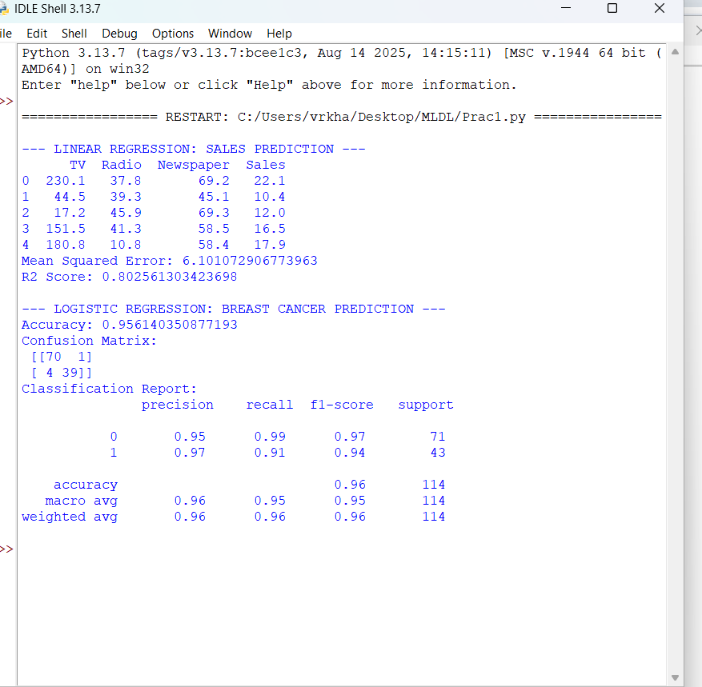

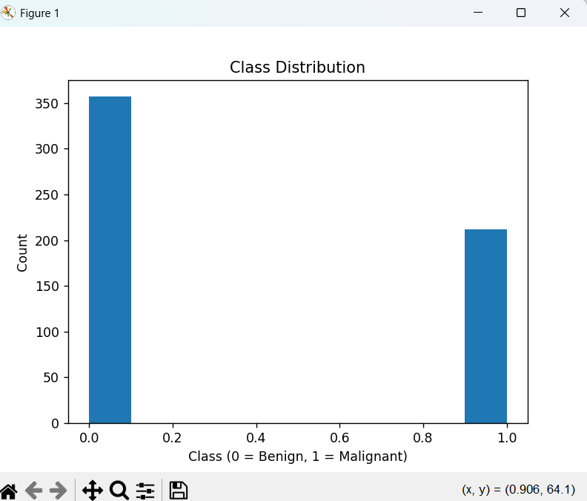
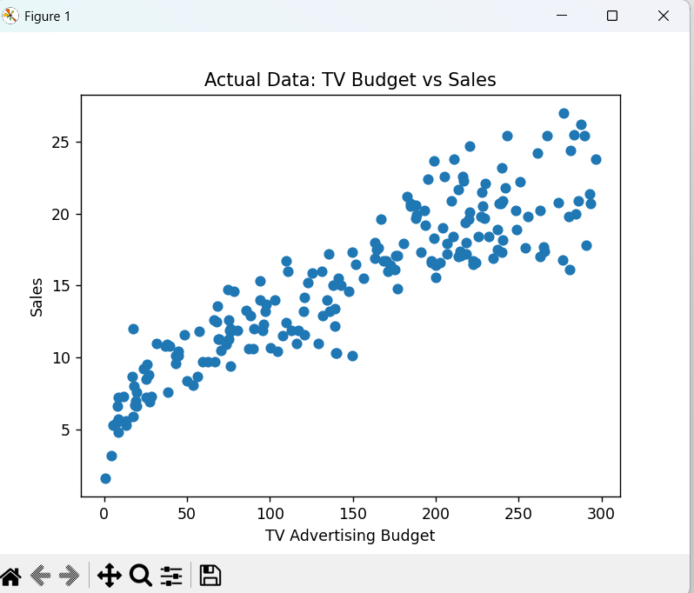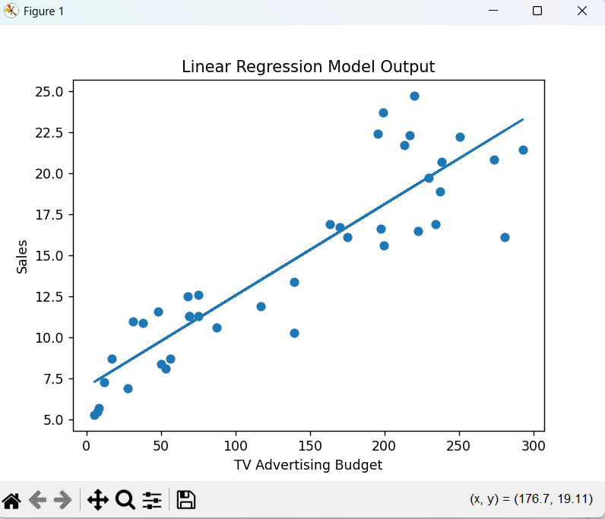

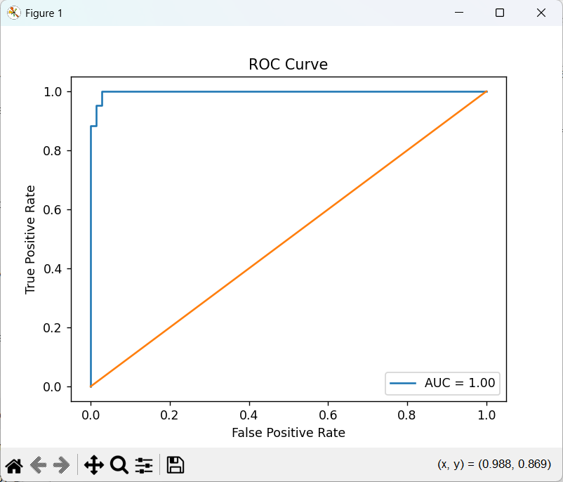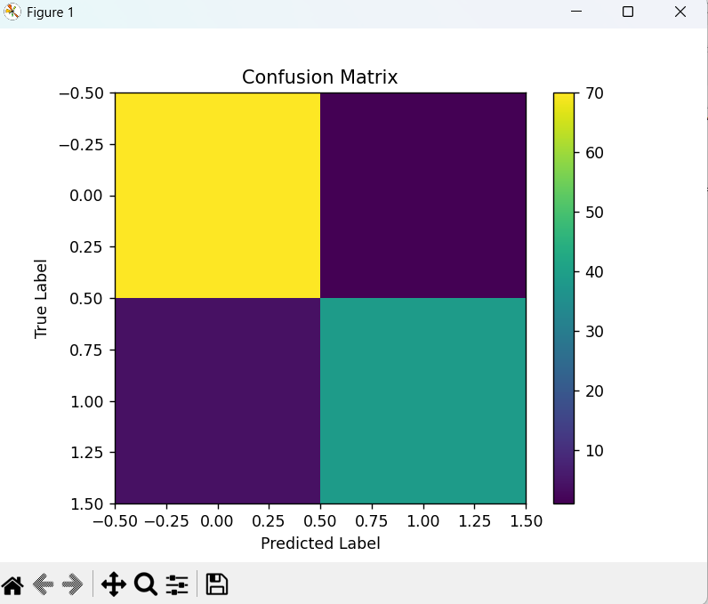

Conclusion
In this experiment, both Linear Regression and Logistic Regression were applied to separate real-world datasets. Linear Regression was used to estimate continuous sales figures, whereas Logistic Regression was utilized to categorize medical outcomes. Various evaluation metrics and graphical representations were employed to assess model performance and better understand their results.

